

**SOFTWARE ENGINEERING SUMMIT**



In preparation of the upcoming Software Engineering Summit each participant will need to install and setup the below required dependencies. Having the below is extremely important to complete prior to the Summit coursework begins as the instructors will not have extra time to walk through these installs in the beginning of their classes.

**Shared Pre-Reqs**

Ensure you have git installed version 2.*, see the following for directions: <https://git-scm.com/book/en/v2/Getting-Started-Installing-Git>

Be sure to have an advanced text editor of your choice installed on your computer, if you do not already have one some suggestions:

* Atom: <https://atom.io/> (Mac Only)
* SublimeText: <http://www.sublimetext.com/> (Mac or Windows)
* NotePad++ <http://notepad-plus-plus.org/> (Windows Only)

**AWS Pre-Reqs**

1. Sign up for an AWS Account (we will be using the free tier, but you need to put in a credit card when you sign up):  <https://aws.amazon.com/free/>
2. Windows Users, please install PuTTy so we can log into the AWS EC2 instances:  <http://www.chiark.greenend.org.uk/~sgtatham/putty/download.html>

*\*If you run into any issues with the AWS Pre-Reqs please contact:* [*renee.seaman@capitalone.com*](mailto:renee.seaman@capitalone.com)

**Parse Pre-Reqs**

1. Sign up for a free Heroku account: <https://www.heroku.com>

2. Add a credit card to your Heroku account (If you don’t have a credit card skip this step – you can partner with someone who does)

- Click on your email on the left panel in the Heroku dashboard > Manage account > Billing

3. Download the Heroku Command Line Interface

- Download and install the Heroku tool belt: <https://toolbelt.heroku.com>

4. Download a preferred text editor if you don’t already have one

- Some suggestions: Visual Studio Code (<https://code.visualstudio.com>), Atom (<https://atom.io>), Sublime (<https://www.sublimetext.com>)

*\*If you run into any issues with the Parse Pre-Reqs please contact:* [*Alexandra.Colevas@capitalone.com*](mailto:Alexandra.Colevas@capitalone.com)

**Android Pre-Reqs**

Download Android Studio: <https://developer.android.com/sdk/index.html>

Once Android Studio is downloaded, launch and go to Tools > Android > SDK Manager > Launch Standalone SDK Manager. Open Android SDK Manager and select the following:  
  
*\*Note: Android Studio may ask if you want to install additional SDKs and Tools during installation… Either way, be sure to use the SDK Manager to select the options below.*

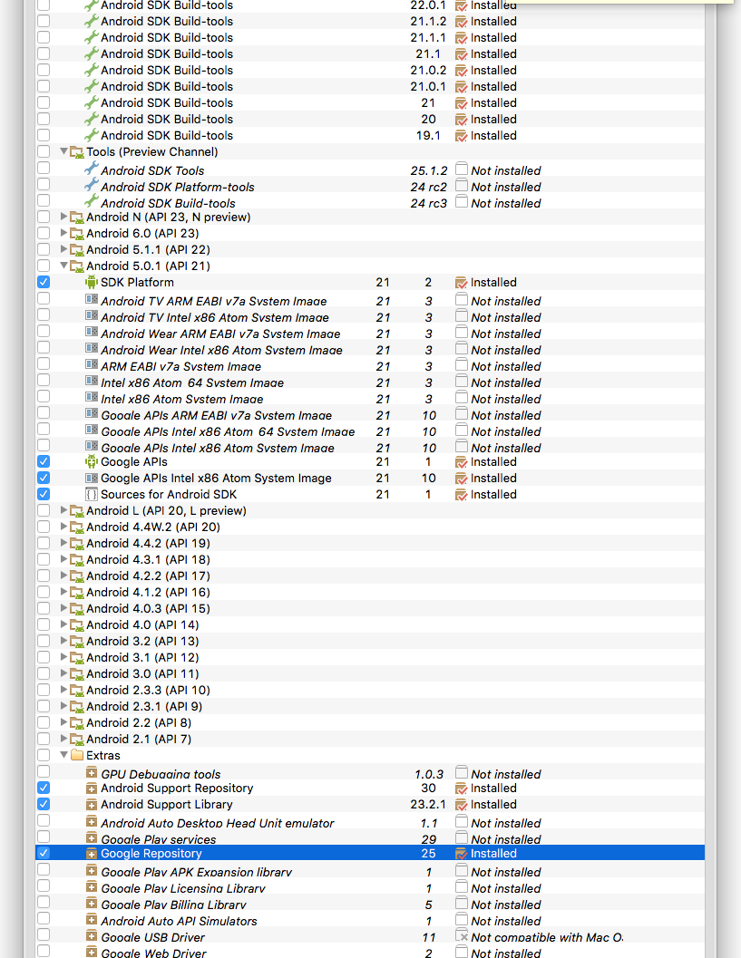

*\*If you run into any issues with the Android Pre-Reqs please contact:* [*katie.thompson@capitalone.com*](mailto:katie.thompson@capitalone.com)

**iOS Pre-Reqs**

Step 1: Register for a free Apple Developer Account here: <https://developer.apple.com/membercenter/>

**Before continuing:**

Note for Mac users-- Please upgrade to Yosemite or later before attempting the below.

PC Users-- Please disregard the below, Xcode is only available for Macintosh so we will be setting up a remote Mac instance for you to use in order to take the course.

For Mac users using Yosemite or later:

Step 2: Download and install Xcode version 7.3.1: <https://developer.apple.com/xcode/download/>

Open Xcode once installed

Click "Create a new Xcode project"

Choose iOS->Application->Single View Application, click "Next"

Enter "HelloWorld" for Product Name, click "Next"

Choose directory to save project into, click "Create"

Run the project in the simulator (click the "Play button") and ensure the simulator opens and displays a white screen with the status bar at the top.

*\*If you run into any issues with the iOS Pre-Reqs please contact:* [*Austin.Lamon@capitalone.com*](mailto:Austin.Lamon@capitalone.com) *and* [*Oluwabori.Oludemi@capitalone.com*](mailto:Oluwabori.Oludemi@capitalone.com)

**React Pre-Reqs**

1. Download the slides from react-c1.md or react-c1.pdf
2. Watch videos while coding along. The videos are in the videos folder at <https://github.com/C1-SoftwareEngineeringSummit/react101>
3. Download and complete the self-paced workshop: <https://github.com/kohei-takata/learnyoureact>
4. Finish the Timer project which is described in the slides and last video.

The courseware’s in the <https://github.com/C1-SoftwareEngineeringSummit/react101> GitHub repository.

*\*If you run into any issues with the React Pre-Reqs please contact:* [*Azat.Mardan@capitalone.com*](mailto:Azat.Mardan@capitalone.com)

**Conversational UI and Bot Development Pre-Reqs**

1. You will receive a Slack team invite, so please make sure you accept it and join the team.

*\*If you run into any issues with the Conversational UI and Bot Dev Pre-Reqs please contact:* [*Jared.Alexander@capitalone.com*](mailto:Jared.Alexander@capitalone.com)

**Blender Pre-Reqs**

To get started with building interactive applications with Blender you'll need a couple of things: the Blender editor itself, a python-3.5+ shell, and enough knowledge of python syntax to do some basic programming. Managing python packages can be done in a variety of ways, but by far the easiest and most common is through "pip", so you should make sure you can run "pip install" commands on your operating system. To keep things neat, you may want to also set up a python virtual environment. Finally, if you usually work with a trackpad but have an external mouse, you may want to bring it along for this session since manipulating objects in Blender's 3D editor can be easier with physical buttons and a scroll-wheel.

Things to Definitely Do

1. download and install Blender 2.77 <https://www.blender.org/download/>
2. download and install python3 <https://www.python.org/downloads/release/python-351/>
3. install pip for python3 <https://pip.readthedocs.org/en/1.1/installing.html>

Things to Figure Out If You've Never Done Them

If you've never used python before, making sure you can do the following will help you spend this session doing interesting stuff rather than wrestling with python syntax.

1. start the python shell and add some variables together
2. write a simple python function and pass it some arguments
3. write a simple python class and instantiate it
4. serve a webpage from a directory on port 9123 with `python3 -m http.server`
5. pip install virtualenv and create a virtual environment for your summit python code

*\*If you run into any issues with the Blender Pre-Reqs please contact:* [*Keelan.Downton@capitalone.com*](mailto:Keelan.Downton@capitalone.com)

**Hardware Class Pre-Reqs**

1. Set-up Instructions <https://github.com/C1-SoftwareEngineeringSummit/Hardware-Class/blob/master/class_notes/class%20prep%20notes.pdf>

*\*If you run into any issues with the Hardware Pre-Reqs please contact:* [David.Wurmfeld@capitalone.com](mailto:David.Wurmfeld@capitalone.com)